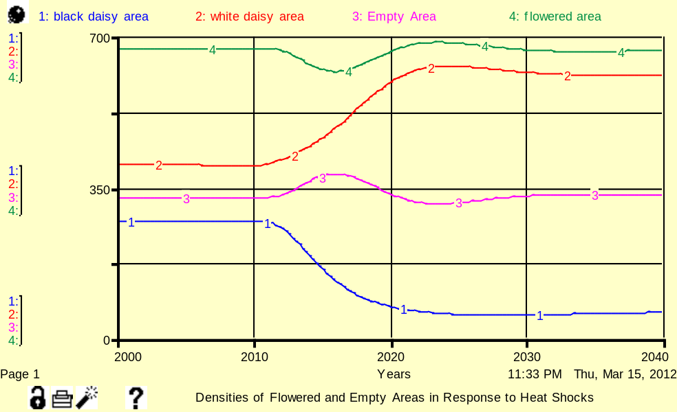
Figure 1.1
This time series graph shows that
white daisy area and black daisy
area remain constant for the first decade, but the former starts to increase exponentially for the next decade, while the latter
decreases. Eventually, by the year
2020, both areas have saturated. During the 2010-2020 time frame, the black daisy area and the white
daisy decrease and increase at a disproportionate rate. This results
in a slight dip in the flowered
area, which in turn, gives the empty area the opportunity to
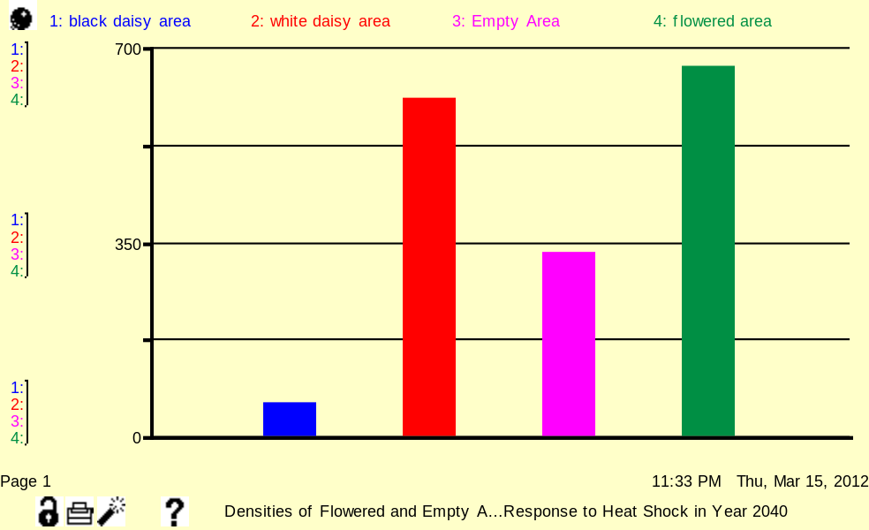
replace the flowered area. Figure 1.2
A heat shock increases the
intrinsic growth rate of white
daisies, but decreases the intrinsic
growth rate of black daisies. The
decay rate for black daisies is
sufficient enough to overtake their
growth. The table confirms that
the white daisy area out-competes the black daisy area after the
the heat shock.
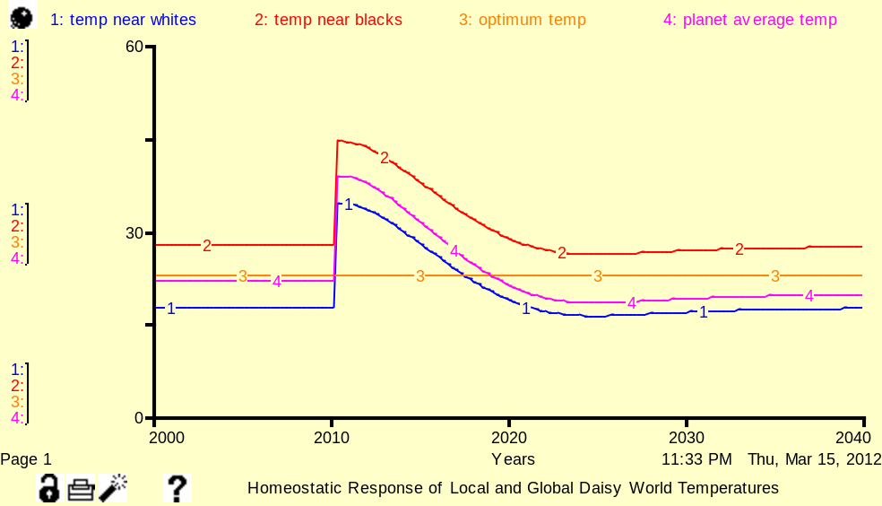

Figure 1.3
Both the local white and black
temperatures and the average
planet temperature are able to
return to a stable temperature
close to their initial values. That
is, Daisy World is able to control the proportions of black and white
daisies in order to negate the heat
shock. Planet average
temperature self-regulated.
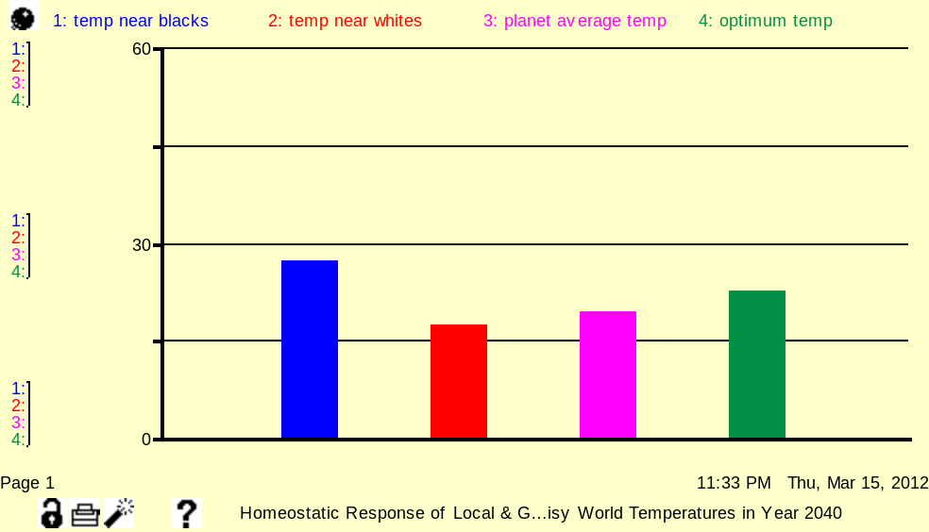
Figure 1.4
The black daisies, which absorb
solar luminosity, are of higher
abundance than white daisies.
White daisies have a higher
albedo than black daisies and
thus reflect more incoming solar
energy. As such, temperature
near the white daisy area is lower
than the black daisy area. The reflective quality of the white daisies gradually neutralize the
heat shock.

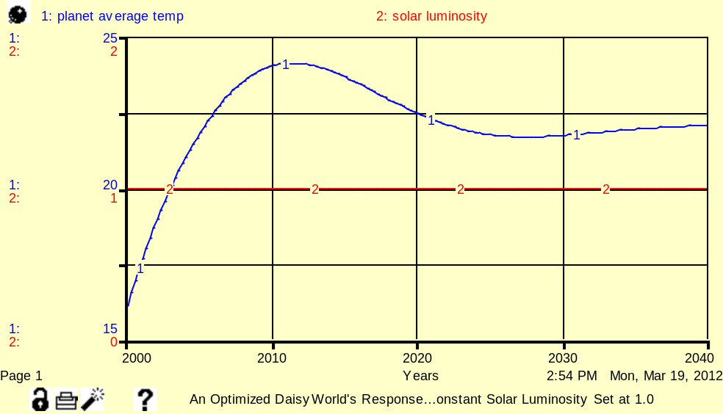
Figure 5.1
With solar luminosity constant at
1.0, the planet average
temperature’s high value would
be initially offset by the high
albedo of permafrost. But
prolonged exposure to an
increasing local permafrost
temperature would result in
gradual melting, until the
permafrost area reaches a new
equilibrium value by the year
2035. As permafrost melts, daisy
world loses its reflective quality,
and temperature increases until
the year 2010 is reached. During this time, white daisy area increases in order to compensate for the loss of permafrost area. The high albedo of white daisies acts as a safety net and helps the dynamic system find equilibrium conditions on its own. Once planet average temperature decreases to a particular level, melting of permafrost area will slow down.
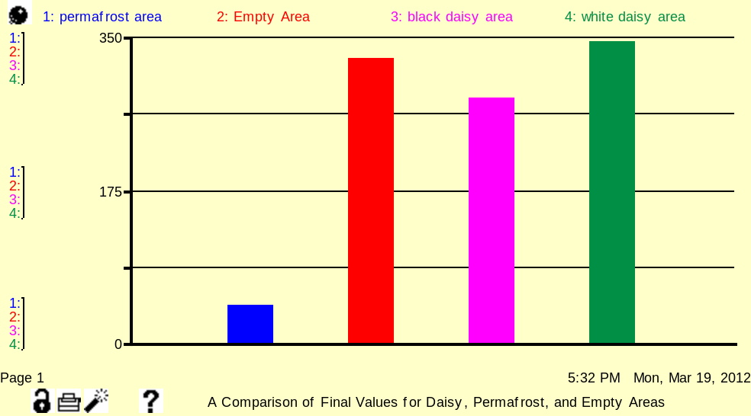
Figure 5.2
This figure confirms that the
melting causes permafrost area to
decrease as local permafrost
temperature increases.
Furthermore, increased melting
leads to more empty area. Daisy world will respond to a rise in
planet average temperature, as
the growth rate of the white
daisy area increases.
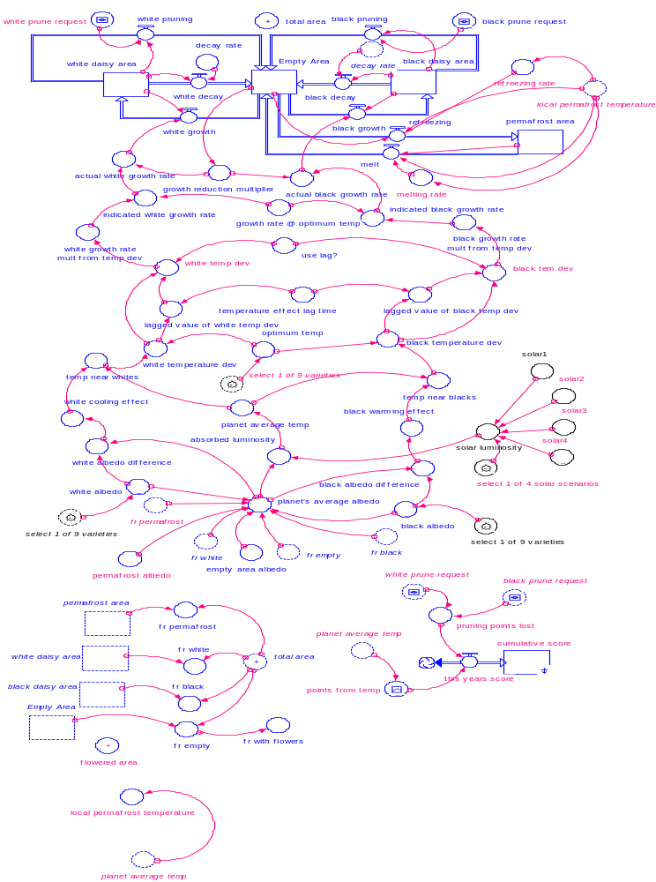

Logical operators were used to show that permafrost area expands
if local temperature is below 0 and shrink if local temperature is
above 0. (Ex. if (local_permafrost_temperature>0) then
melting_rate*permafrost_area else 0). Melting rate and refreezing
rate were used using formula, melting rate = melt rate coefficient
*(change in temperature) and refreezing rate = refreezing
coefficient*(-change in temperature), respectively. To test the
viability of the model, fr_permafrost was plotted against
temperature, which showed an exponential approach pattern.
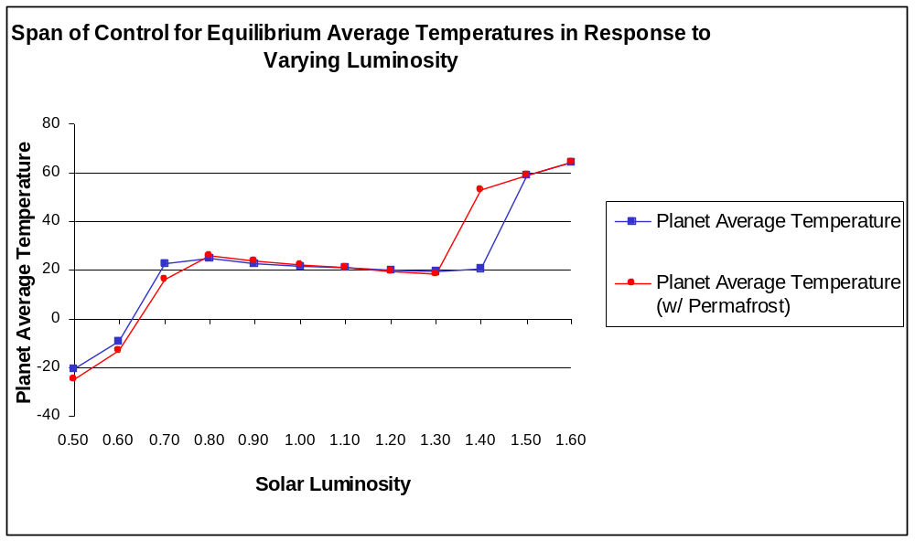

Figure 6.1
The span of control for the original model that did not factor in permafrost ranges from 0.7 to 1.4. With permafrost included, the span of control has a shorter range. When a heat shock produces a jump in solar luminosity from 1.0 to 1.4, DaisyWorld is unable to maintain homeostasis. That is, the world loses its reflective quality and the sharp increase in planet average temperature would be enough to hamper the growth of even the white daisies. Once a solar luminosity of 1.4 is reached, permafrost melts at a continuous rate that cannot be restored and the dynamic system demonstrates run away behaviour. Likewise, if solar luminosity is below 0.70, the black daisies decay and the world loses its absorptive power. Permafrost does nothing to alleviate the situation because it has a high albedo that reflects incoming solar radiation.

Span of Control (Stock added) Span of Control (Stock = Converter)
solar_luminosity | Planet Average Temperature | solar_luminosity | Planet_average_temp
0.5 | -20.8 | 0.5 | -20.8
0.6 | -9.1 | 0.6 | -9.1
0.7 | 22.5 | 0.7 | 22.5
0.8 | 25 | 0.8 | 25.1
0.9 | 22.9 | 0.9 | 22.8
1 | 21.8 | 1 | 21.8
1.1 | 21 | 1.1 | 21
1.2 | 20 | 1.2 | 20
1.3 | 19.2 | 1.3 | 19.4
1.4 | 20.6 | 1.4 | 20.7
1.5 | 58.9 | 1.5 | 58.9
1.6 | 64.3 | 1.6 | 64.3

Transcending Beyond Lovelock’s Gaia Hypothesis and DaisyWorld’s Homeostatic Control

The juxtaposition between the original DaisyWorld Flight Simulator and Permafrost-DWFS models demonstrates the power of homeostasis and its ability to resist perturbations such as heat shocks. To counteract such disturbances, the system manipulates the proportions of black daisy, white daisy, and permafrost populations, which in turn, allows the system to find an equilibrium state. However, the results gathered from various figures imply that once heat shock passes a designated threshold, DaisyWorld’s ability to maintain its homeostatic control mechanism will be compromised and as a result, a vicious circle will ensue. Both the aforementioned models enable self-regulation of the planet’s average temperature. In the case of the Permafrost-DWFS model, DaisyWorld is able to fall back on the high albedo of white daisies should permafrost area reach an insufficient quantity, in which the latter is unable to produce a reflective barrier that stabilizes the higher temperatures associated with a heat shock. Such a trade-off comes with some penalties. Various shortcomings can be observed in the Permafrost-DWFS’s span of control which highlights the inability of DaisyWorld to accommodate a jump in solar luminosity to a value of 1.4.

In accordance with the original model, the Permafrost-DWFS model is able to find a balance between insolation and flowered areas to modulate the global temperature. By correlating figure 1.2 with figure 5.2, it can be easily discerned that white daisies are of paramount importance in resisting an increasing planetary temperature. As temperature increases, white daisy growth will increase accordingly and white daisies will eventually outnumber the black daisies. The white daisies form a reflective wall that prevents most of the solar luminosity from entering DaisyWorld. Incidentally, the high albedo of white daisies induces a cooling effect that allows the system to find a stable equilibrium. Figure 5.1 verifies that a constant luminosity disturbs the system by increasing temperature. Since temperature imposes negative feedback on the permafrost area, as temperature increases, permafrost cover will recede. As permafrost albedo contributes greatly to the planetary albedo, DaisyWorld will be stripped of its reflective power and the white daisy area will overtake the black daisy area to compensate for the loss in permafrost albedo, as shown in figure 7.3. The increase in white daisy area will induce positive feedback on planetary albedo, which in turn will impose negative feedback on the fraction of luminosity absorbed. As such, both the planetary temperature and local permafrost temperature will decrease and permafrost area melting will decrease correspondingly.

Including permafrost creates a more realistic model, which explores the notion of “destabilizing feedbacks” (Ford, 2010). In the Permafrost-DWFS model, there is a reinforcing feedback loop that acts to accelerate the loss of permafrost area, which in turn dissipates its reflective power. Once solar luminosity and temperature are at a sufficient level, this reinforcing loop will attain loop-dominance and further reinforce the impact of the heat shock. For example, the diminishing of permafrost albedo decreases the planet’s average albedo, and thus more solar luminosity is absorbed by DaisyWorld, leading to higher temperatures. The cycle repeats itself with permafrost area continuing to decline in response to increasing local permafrost temperatures. The addition of this reinforcing feedback loop emphasizes the fragility of the Permafrost-DWFS model, in which forced heating beyond the tipping point of the dynamic system would lead to run-away behaviour, in which both local permafrost and global temperatures would increase uncontrollably. This is seen in figure 6.1, which shows the correlation between equilibrium average temperatures and incoming solar luminosity. The Permafrost-DWFS model’s span of control shows its inability to control temperature once solar luminosity hits a value of 1.4, in stark contrast to the original model which could rely on the growth of white daisies and their reflective power early on.

The original model contains 2 reinforcing loops which induces positive feedback on the dynamic system, and acts to accelerate the growth of black and white daisies. However, the original model also has 6 balancing loops to keep flowered area growth in check. That is, black daisy decay and white daisy decay will act to minimize the growth of both flowered areas. As well, saturation of the empty area will decrease the growth reduction multiplier which in turn, negatively interferes with white growth and black growth. Finally, both white and black growth rates are temperature-dependent. 2 balancing loops act to slow the growth rates of both white and black daisies should their local temperatures fall further away from the optimum temperature. A decrease in the growth of both black and white daisies will also decrease the planet’s average albedo, which consequently decreases global temperature. This decrease in temperature will favour black daisy growth, and its associated absorptive properties will result in an increase in temperature. These multiple cascading effects interact with each other in order to restore the system to its original equilibrium position should a disturbance be introduced. In reference to figure 1.3, the interconnectedness of white daisy growth, black daisy growth, their albedo, and the planet’s temperature acts to neutralize the spike in temperature. It takes about a decade for the DaisyWorld find the equilibrium conditions on its own, and it does so by carefully rearranging the abundances of white and black daisies. When the global temperature is too high, white daisies will out-compete black daisies and their reflective power will prevent the global temperature from reaching unprecedented heights. Conversely, the permafrost-DWTS model lacks a balancing causal loop to constrain the positive feedback between temperature and permafrost area.

Unlike the original model, a close direct linkage between temperature and permafrost presents some severe repercussions. While permafrost refreezing exists in the model, it is rendered inactive under warmer local temperatures. As suggested in figure 7.1, both melting rate and refreezing rate depend on temperature. The refreezing balancing loop will be rendered inactive if temperature is greater then zero. Thus when the heat shock triggers on-going permafrost melting, the negative feedback exerted by refreezing will do virtually nothing to abate the melting process. The permafrost-DWTS model shows the inconsistencies of the refreezing balancing loop which overly relies on temperature to be below 0. In the original model, the balancing loops were both temperature and density-dependent; one or the other could restrain an effect of the system.

As a self-regulating feedback system, both DaisyWorld models are able to respond appropriately to the effects of increasing solar luminosity on flowered areas. However, both models suggest that limitations exist in the form of run-away behaviour. That is, when forcing from solar luminosity exceeds the tipping point of the system, daisies die out, and global temperature increases uncontrollably. The inclusion of permafrost illustrates an underlying destabilization of the DaisyWorld model. Just as in the original model, the white and black daisy populations are vulnerable to temperature past a particular threshold. But in this hypothetical scenario, temperature also imposes positive feedback on the permafrost area. Permafrost eventually recedes to a point where the DaisyWorld model is unable to modulate the planet’s average temperature. This deficiency is underlined in the span of control where the reinforcing loop comprised of permafrost albedo, fraction of luminosity absorbed and local permafrost temperature accelerates the planetary temperature.

Additional Figures
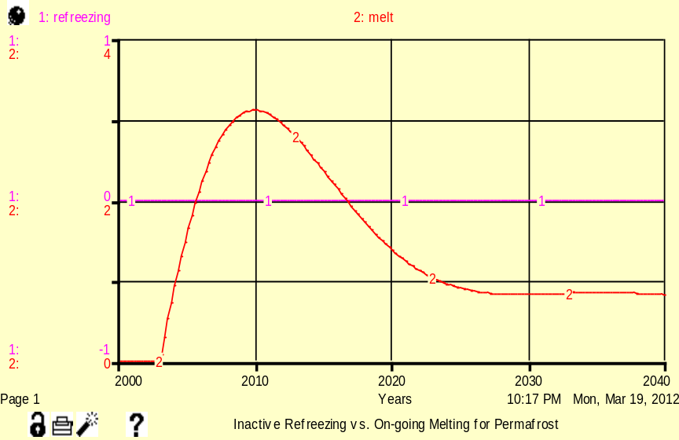

Figure 7.1
This figures shows that under a constant
luminosity of 1.0, melting of permafrost
will increase with time, and peaks around
the year 2010. Afterwards, it will
gradually decrease and reach a stable
equilibrium by the year 2025.

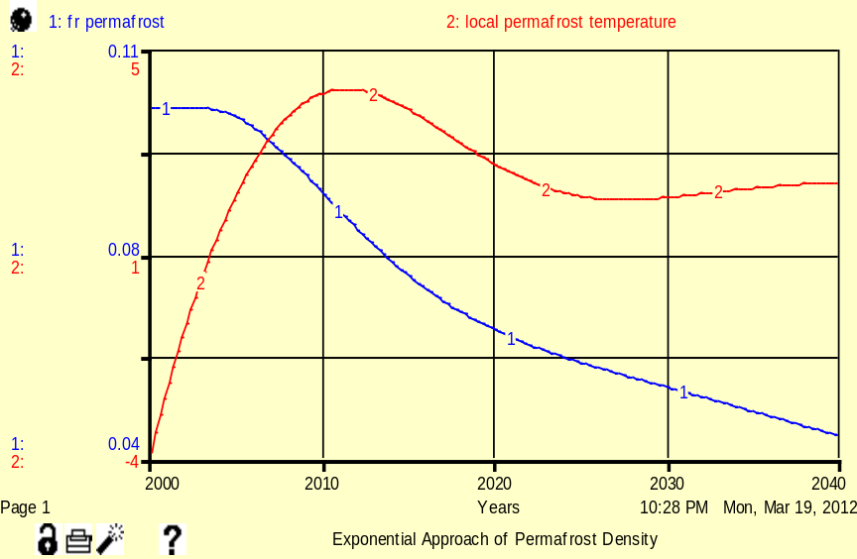

Figure 7.2
This figure demonstrates the
correlation between permafrost
and temperature. Fraction of permafrost
area declines as temperature rises.

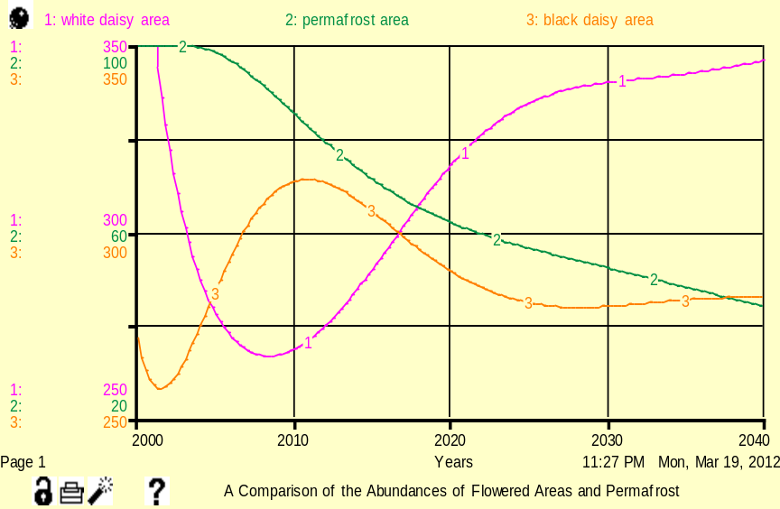
Figure 7.3
As permafrost decreases due to melting,
a growth in the white daisy area
compensates for the loss of permafrost
reflective quality. The black daisy area
declines as white daisy area increases.

